***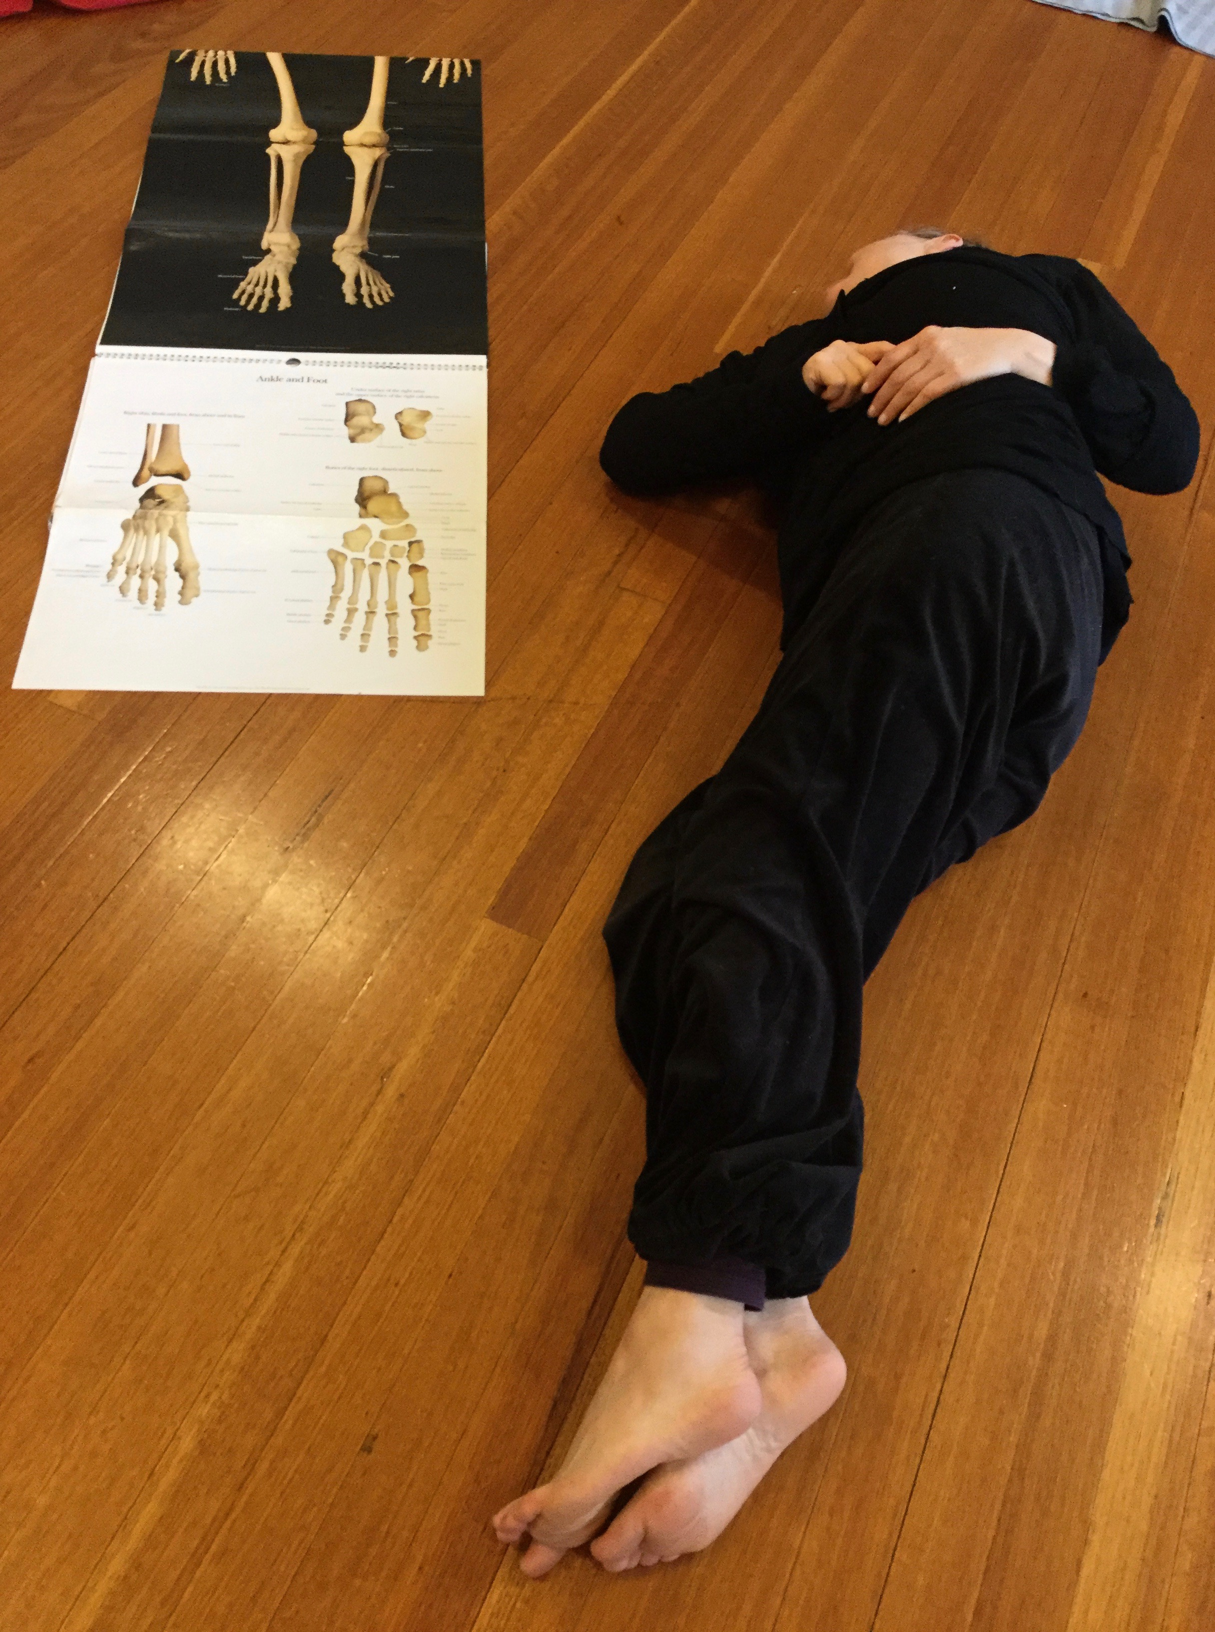Macintosh HD:Users:alicecummins:Dropbox:A DATA 2010-20:Footfall:Admin:Admin Support:Janette Hoe:Master Files:AliceCummins LOGO MASTER FILES:Print Use:ACummins LOGO_CMYK_for print.eps***

Body-Mind Centering®

7-week series

4 May – 15 June 2022(7 weeks)

Green Monday Studios

73 Grattan St Carlton

Wednesdays 10.30am – 12.30pm

Cost: $350

******

*Engaging and revitalizing through a moving exploration of the anatomy & poetics of your bodymind*

How do we begin again – to meet, dance and touch one another? In the aftermath of the past two years how do we gather into our selves and cultivate the practice of *being with* one another to move, create and find our belonging? I propose that this practice can support us redefining ourselves and how we navigate our way through. The vulnerability we have all experienced is at the heart of our return and renewal, remaining present as we renogotiate our lives. My teaching is infused with the philosophy of self-organisation and relational life. As we find our deepest connection to ourself, others and the lived world we re-pattern our belief systems and invite questions about our role and place in the lived world. The offerings are infused with ethics|aesthetics and the capacity for transformation is cultivated between us all.

Body-Mind Centering® (BMCSM) is a study of the experienced body in contrast to the objectified body. It is an embodied approach to learning, living and knowledge making. BMC engages the bodymind through the poetics of moving, touch and experiential anatomy, inviting change that is an integration of our physical, psychological, intellectual and imaginative life.

*Thank you for holding the space of this profound work.*

Fiona H – gardener | landscape architect | researcher

Alice Cummins MA, is a dance artist, BMCSM Practitioner and Registered Somatic Movement Educator & Therapist. She has been researching and teaching her work nationally and internationally for over twenty years. Her process creates an environment of refined somatic awareness and generates engagement and embodied intelligence within a community of shared inquiry. Alice is the director of [Somatic Wisdom](http://www.alicecummins.com/introduction), a registered training program with [ISMETA.](https://ismeta.org/)

"Body-Mind Centering®" and "BMCSM" are service marks of Bonnie Bainbridge Cohen, used with permission.

Direct PaymentAlice Cummins, NAB

BSB: 082057

ACC: 559585230

*Confirmation will be sent on receipt of payment*

Further Enquiries0419 227 800

[www.alicecummins.com](http://www.alicecummins.com)

alice@footfall.com.au

**­­**