***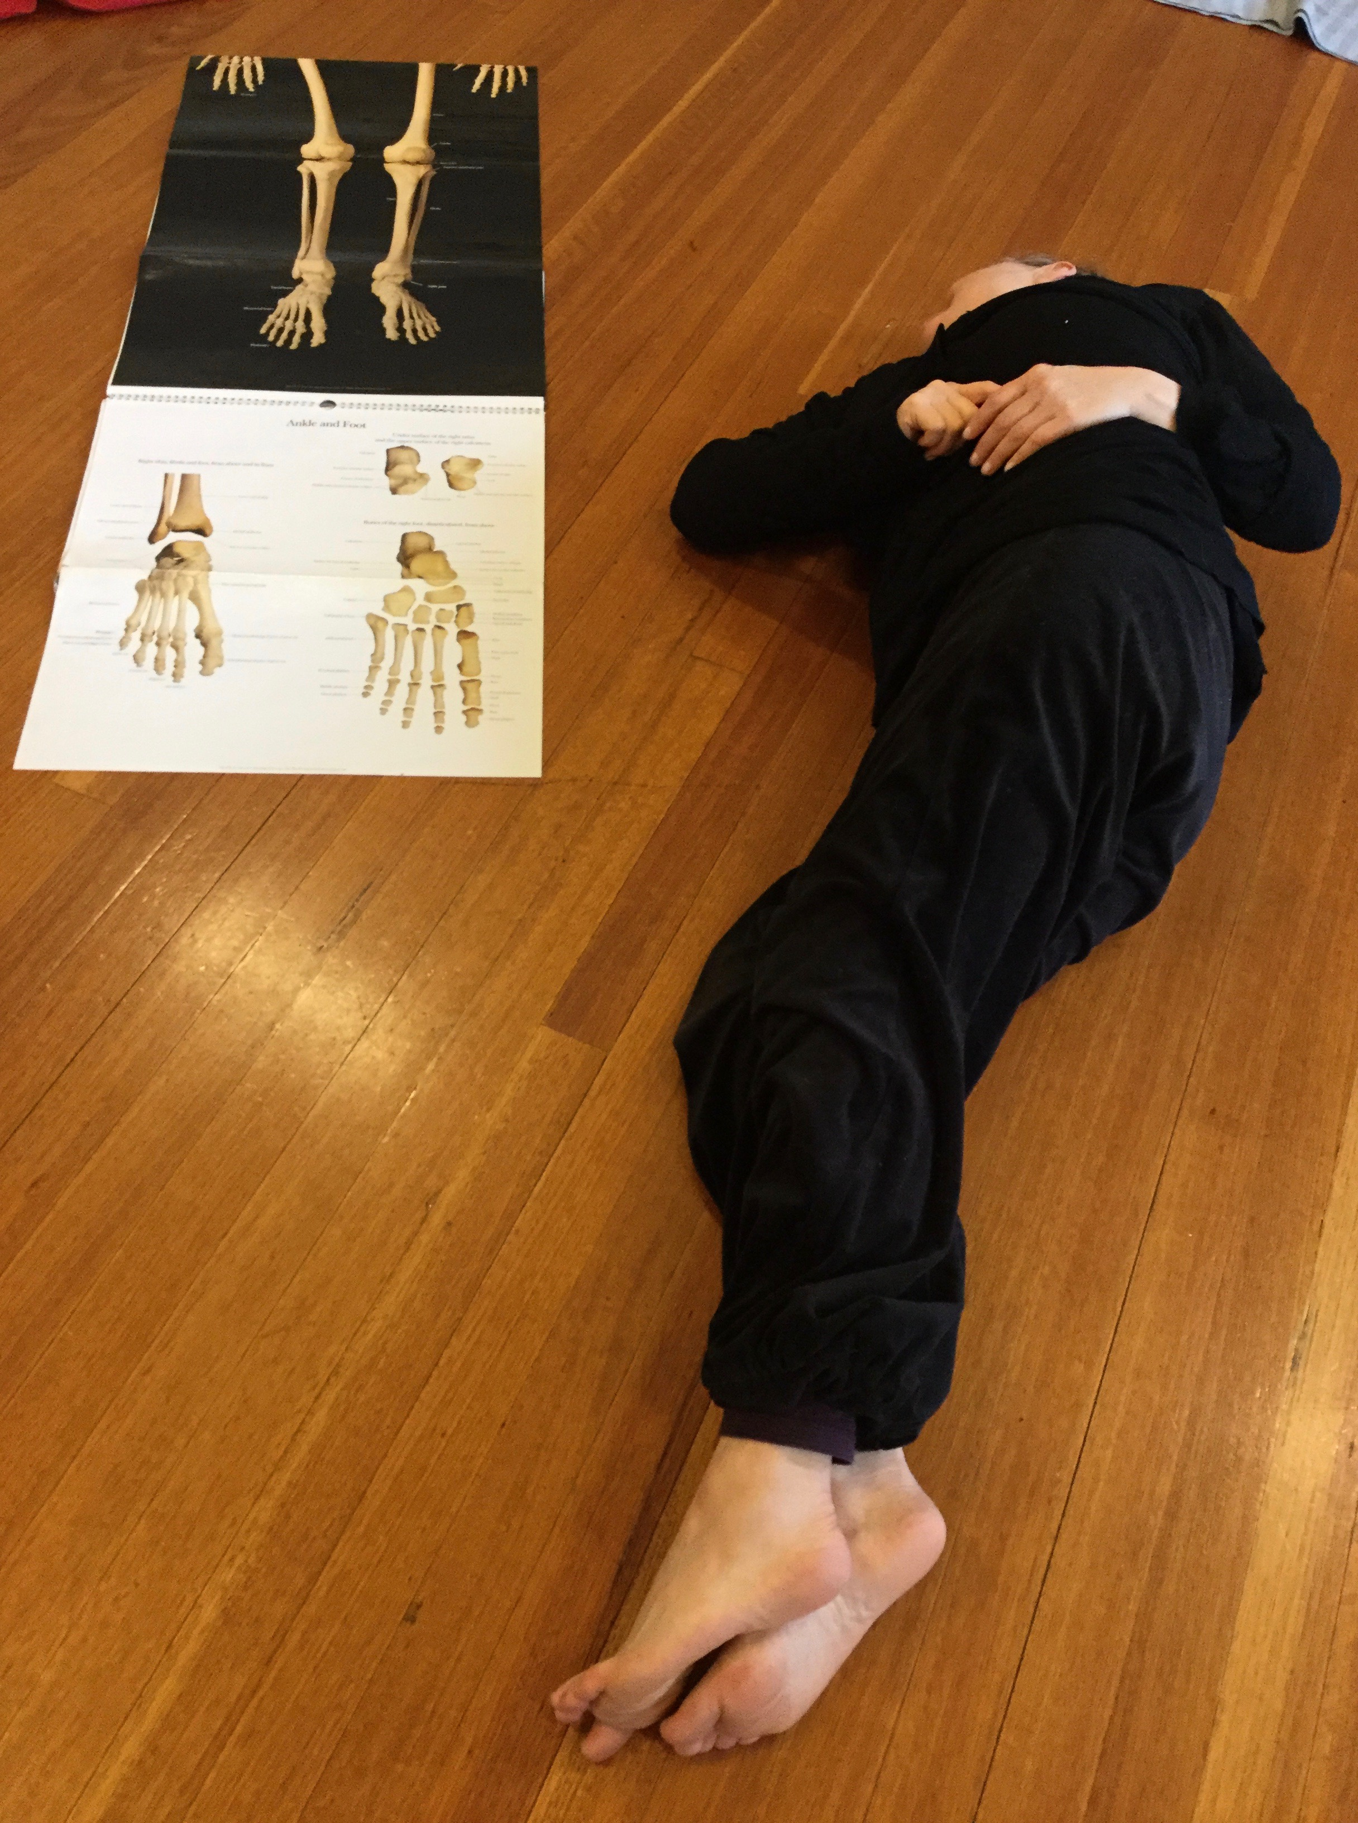Macintosh HD:Users:alicecummins:Dropbox:A DATA 2010-20:Footfall:Admin:Admin Support:Janette Hoe:Master Files:AliceCummins LOGO MASTER FILES:Print Use:ACummins LOGO_CMYK_for print.eps***

Body-Mind Centering®

7-week series

Exploring the anatomy & poetics

of your bodymind

7 April – 19 May 2021(7 weeks)

Dancehouse – 150 Princes St North Carlton

Wednesdays 10.30am – 12.30pm

Cost: $350

******

*The history of the body is the history of human beings, for there is no cultural practice that is not first applied to the body.*

Silvia Federici – “In Praise of the Dancing Body*”*

*Beyond the Periphery of the Skin*

7-WEEK SERIES: Beginning with the premise that movement is perception, we will rigorously engage with different Body-Mind Centering® principles. Through a practice of listening and attention you will develop somatic awareness. The workshops will include guided movement, anatomical information, imagery and directed self-touch, followed by Authentic Movement, shared discussion, and journal writing to integrate the material.

Body-Mind Centering® (BMCSM) is a study of the experienced body in contrast to the objectified body. It is an embodied approach to learning, living and knowledge making. BMC engages the bodymind through the poetics of moving, touch and experiential anatomy, inviting change that is an integration of our physical, psychological, intellectual and imaginative life.

*Thank you for holding the space of this profound work.*

Fiona H – gardener | landscape architect | researcher

Alice Cummins MA, is a dance artist, BMCSM Practitioner and Registered Somatic Movement Educator & Therapist. She has been researching and teaching her work nationally and internationally for over twenty years. Her process creates an environment of refined somatic awareness and generates engagement and embodied intelligence within a community of shared inquiry. Alice is the director of [Somatic Wisdom](http://www.alicecummins.com/introduction), a registered training program with [ISMETA.](https://ismeta.org/)

"Body-Mind Centering®" and "BMCSM" are service marks of Bonnie Bainbridge Cohen, used with permission.

Direct PaymentAlice Cummins, NAB

BSB: 082057

ACC: 559585230

*Confirmation will be sent on receipt of payment*

Further Enquiries0419 227 800

[www.alicecummins.com](http://www.alicecummins.com)

alice@footfall.com.au

**­­**