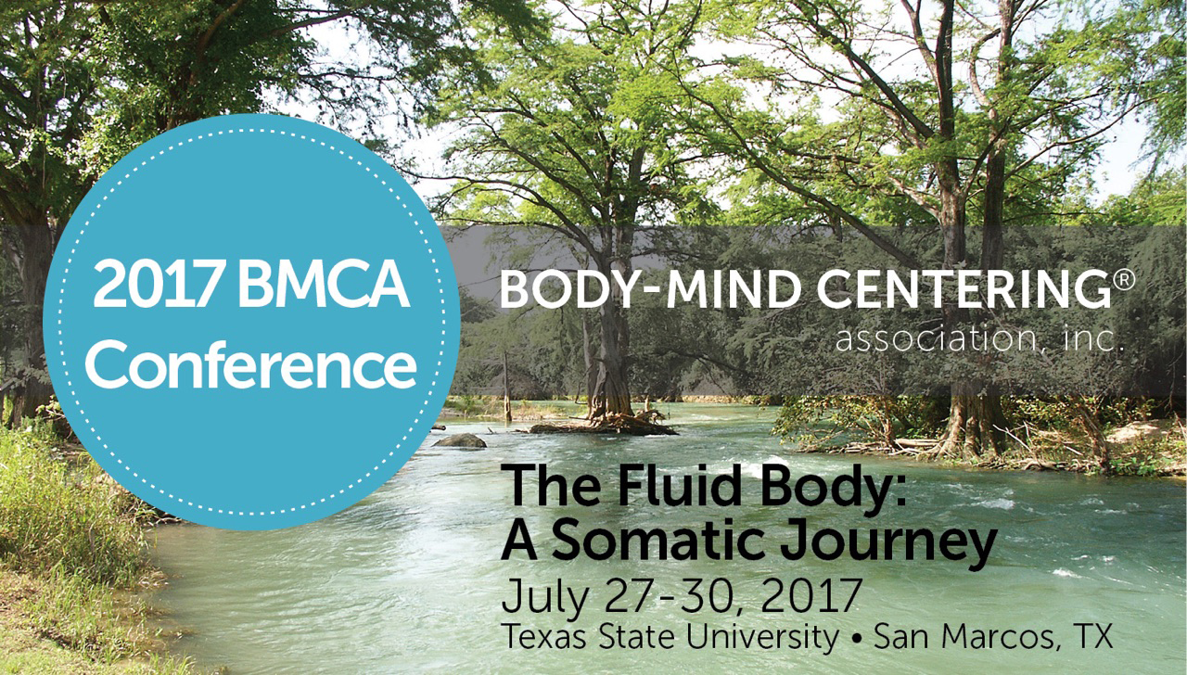

Welcome to the Conference!

www.bmcassociation.org/conferences

Please see some helpful suggestions and links below for your stay at Texas State University in San Marcos, Texas.

Your Registration Information
To adjust your registration, click the registration link on the BMCA website (www.bmcassociation.org/conferences) and enter your email and password. Then click ‘Dashboard’ by your name and ‘Conference Information-Registration Information.’

Check-in/Arrival:
We recommend you arrive a couple of hours before the start of the conference to allow you to check into the conference, locate your dormitory housing if you are staying on campus, and eat lunch.

If you are staying on campus, please see the check-in instructions under the housing section on page 2.

Check-in for the conference is in the foyer of the Jowers Center located at Jowers Access Road, San Marcos, Texas.

The registration desk hours are as follows:
Tuesday, July 25, 12 noon to 5:30 PM
Wednesday, July 26 – Sunday, July 30, 8:00AM to 6:00 PM
- All conferees must check-in and be paid-in-full before attending any workshops.
- We recommend you arrive early to allow enough time to check-in and get oriented.

Housing
For those with reservations for on campus housing, please check-in with the Conference registration desk located in the foyer of Jowers Center to pick up your room key and campus card to Lantana Residence Hall. If you arrive outside of BMCA Conference registration desk hours, please call the number posted at the residence hall for assistance.
Some important information for those staying in Lantana Hall:
- All rooms are air-conditioned.
- All rooms share a communal hall bathroom.
- All rooms contain a twin size bed, desk, chair, dresser, and closet.
- Rooms do not include any linens or a pillow. Please be sure to bring your own sheets for a 76” long twin bed, a light blanket if needed, towels, a pillow, and any toiletries.
- We will have a limited number of pillows for sale ($7) at the registration desk. If you would like to reserve one in advance, please email Ellen.
- Rooms can be viewed at: http://www.reslife.txstate.edu/livingoptions/options/lantana.html
- Free wifi is available in the dorm lobby and all conference buildings. To access a free internet connection in your dorm room, please be sure to bring an Ethernet cable.
- Each hall in the dormitory provides access to a kitchen with a very limited number of pots and pans and refrigerator for all hall residents. No dinnerware (plates, utensils, glasses, etc.) is provided.
- Local grocery stores are a 10-15-minute walk from the dormitory.
- Texas State University replacement fee for a lost key is $50.
- Texas State University replacement fee for a lost access card is $30.

Travel to and around San Marcos and Texas State University:
Conference location:
Texas State University
Jowers Center
Jowers Access Road
San Marcos, Texas 87666
Type in “Jowers Center, Jowers Access Road, San Marcos” to GPS

Campus general address:
Texas State University:
601 University Drive
San Marcos, TX 78666
Phone: 512-245-2111

Airports near San Marcos, TX:
- Austin-Bergstrom International Airport (AUS-Austin, TX):
http://www.austintexas.gov/airport
- San Antonio International Airport (SAT-San Antonio, TX): http://www.sanantonio.gov/SAT.aspx

Travel options to/from the airports to Texas State University campus:
There are many options for bus, transportation companies, shuttles, limousines, rental cars from both airports. To find full information, visit the sites listed below.
For Austin-Bergstrom, visit: http://www.austintexas.gov/department/ground-transportation
For San Antonio International, visit: http://www.sanantonio.gov/SAT/GroundTransportation.aspx
- SuperShuttle will cost about $60+ each way.
- Taxis vary in cost from $45-100+ each way
- Lyft and Uber do not operate in Austin but are available in San Antonio and San Marcos. Austin does have a number of alternative transportation companies listed at the above links.

Weather:
The weather usually averages about 95 degrees Fahrenheit during the day and 75 degrees Fahrenheit during the evening in July. An umbrella for sun protection is highly recommended for outdoors. All indoor spaces are air-conditioned.

Wifi Access and Cell Phone coverage:
Wifi is available campus-wide in campus buildings and the common rooms of the dormitory. Please bring an Ethernet cable if you would like to connect to the internet from your dormitory room. There is excellent coverage on and off campus.

What To Bring:
If possible, bring a yoga mat, water bottle, light blanket, sunscreen, umbrella for sun protection, and any vitamins, supplements or medications you need. Wear comfortable clothes you can easily move in. Conferees will have access to the Texas State University gym however it is a 15-minute walk, uphill from the conference area.
If you are attending Barbara Dilley’s pre-conference workshop, please bring a meditation pillow or blanket so you can sit comfortably.
Please also bring items to donate to the Silent Auction! These could include: certificates for sessions, crafts, books, jewelry, music, art, hand-made items, and more.

Dining
Texas State University cafeteria will be open to all conferees and accepts cash and credit cards at the door. No pre-order is necessary. The dining hall is about a 15-minute walk from the conference building and a 5/10-minute walk from the dorms.
- For restaurants within a 5/10-minute walk to Texas State University Campus, visit: http://www.toursanmarcos.com/dining/index.html

Parking

On campus parking is available for $6 for the week, Monday, July 24 through Sunday, July 30, 2017. Parking (Tower Garage 106) is a 10-minute walk from the conference center (Jowers Center). Those staying in the dorms are welcome to park in the back of the BMCA-assigned dormitory, Lantana Hall, which is about a 5-minute walk from the conference center.

Photography/Videography Policy
Please be advised that no photography or videography will be permitted in any workshops or conference offerings. Only BMCA hired or appointed photographers/videographers will be permitted to take photos or videos in any workshop or at any conference event. Photographs are permitted outside of designated workshop spaces by all participants.

Fun activities in San Marcos and the surrounding area:

The San Marcos river runs right through the Texas State University campus and provides lots of fun activities and attractions!

Tubing:

For a fun trip floating down the river on a tube (about 3 hours) and be transported back to campus, visit:

Tube San Marcos: http://www.tubesanmarcos.com

Glass-bottom boat ride down the San Marcos from campus:

The Meadows Center for Water and the Environment: http://www.meadowscenter.txstate.edu/Education/Glass-BottomBoats.html

Swimming:

Rio Vista Park: http://www.toursanmarcos.com/attractions/outdoors/rio-vista-park.html

Swim in the river or city indoor pool (http://www.ci.san-marcos.tx.us/index.aspx?page=229)

Just a short walk from campus

Live music and Nightlife:

For a listing of local hot spots, music venues, breweries, and places to grab a drink, visit:

http://www.toursanmarcos.com/attractions/index.html

Attractions:

For a listing of art galleries, museums, cafes and antiquing, visit: http://www.toursanmarcos.com/attractions/index.html

Shopping:

http://www.toursanmarcos.com/attractions/index.html

Premium Outlet shopping in downtown San Marcos

Austin is also 30 miles from San Marcos and offers lots of restaurants, music, and fun!

Contact Information and quick info sheet:

Texas State University main phone number: 512-245-2111

Erica Howard Erica@bmcassociation.org
BMCA Conference Administrator 425-652-9934 (cell)

Ellen Ferris, operations@bmcassociation.org (preferred method)
BMCA Director of Operations 413-552-8161 (cell)

Toni Smith, tsmith818@nycap.rr.com
Conference Committee Chair

Conference Location: Jowers Center, Texas State University,
Jowers Access Road, San Marcos, Texas

Texas State University Dorm: Lantana Hall

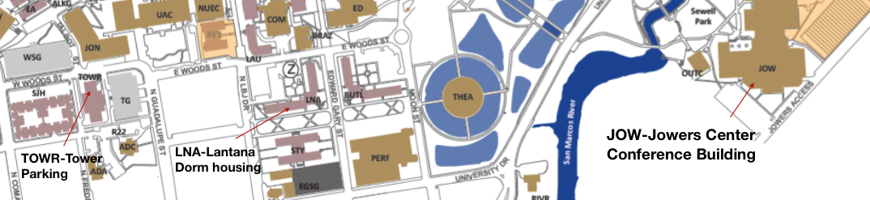

Body-Mind Centering® and are registered service marks and BMCSM is a service mark of Bonnie Bainbridge Cohen, used with permission.

