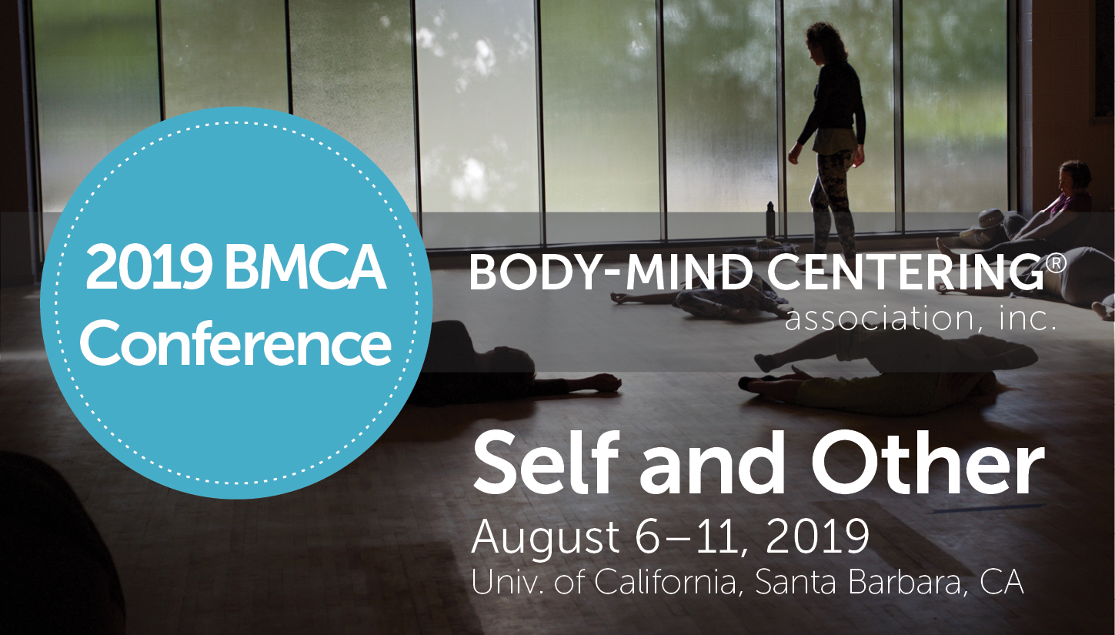

Conference Information:

Dates, Fees, Accommodations, Dining, Travel, Santa Barbara Attractions, What to Bring, Map of Conference Locations, Check-in-Arrival Procedures

www.bmcassociation.org/conferences
Updated October 1, 2018

Dates:

Pre-Conference Workshop:

Ann Cooper Albright, TBD
Tuesday, August 6 (2-5:00 PM) and Wednesday, August 7 (9:00 AM-12:00 PM)

Main Conference:

Wednesday, August 7, 2:00 PM to Saturday, August 10, 12:00 pm

Post-Conference Workshop:

Bonnie Bainbridge Cohen, TBD
Saturday, August 10 (2-5:00 PM) and Sunday, August 11 (9:00 AM-12:00 PM)

Check-in/Arrival
We recommend you arrive a couple of hours before the start of the conference to allow you to check-in at the conference registration desk, settle in to your dormitory housing, and eat lunch. All conferees need to check-in at the conference registration desk to receive conference information packets. If you are staying in the Sierra Madre Apartments, your key and housing information will be waiting for you at your residence.

The Conference Registration desk hours at the Humanities Social Sciences and Performing Arts Building (HSSB) on the UCSB campus are as follows:
Monday, August 5 and Tuesday, August 6: 9 am to 6 pm
Wednesday, August 7 through Saturday, August 10: 8 am to 6 pm
Sunday, August 11: 8 am to 1 pm
- All conferees must check-in and be paid-in-full before attending any workshops.

Fees:
Main Conference
- If registering prior to April 15, 2019, a non-refundable $150 deposit is required and will secure your discounted registration and place at the conference. All registrations after April 15, 2019 require full payment.
- All payment balances are due on or by April 15, 2019.
- Please note, main conference fees do NOT include the pre- and post-conferences, meals or accommodations.
- The fees and additional generous BMCA, BMCSM and current UCSB faculty and student discounts are listed below.

Early Bird Registration through January 15, 2019 | $400
Registration by April 30, 2019 | $500
Registration by July 31, 2019 | $600
Registration on or after August 1, 2019 | $700
Presenter’s Registration | $300

DISCOUNTS
If applicable, one of the following discounts can be applied to your registration:

Current BMCA Members | -$50
BMCA Members who do not reside in North America | -$75
Students currently enrolled in BMC Certification Programs | -$25
Current UCSB Faculty and students | -$50

Pre-Conference:
Tuesday, August 6 (2-5:00 PM) and Wednesday, August 7 (9:00 AM-12:00 PM)
Cultivating the 3Rs: Responsiveness, Resistance, Resilience
Presenter: Ann Cooper Albright
$125

Post-Conference:
Saturday, August 10 (2-5:00 PM) and Sunday, August 11 (9:00 AM-12:00 PM)
TBD
Presenter: Bonnie Bainbridge Cohen
$150

Accommodations:

Housing reservations deadline April 15, limited housing available after this date
UCSB’s Sierra Madre Apartments (http://www.conferences.ucsb.edu/sierra-madre-villages) offer single bedrooms in shared apartments or shared bedrooms in shared apartments. Sierra Madre Apartments are about 1.5 miles from campus and the closest bus stop with buses to campus is a 5-minute walk. Rooms can be booked directly on your registration form. For full information, visit the link above.
- Room rates are: $60 per night for a shared room in a shared apartment and $100 for a single room in a shared apartment.
- Please be aware there is a 2-night minimum.
- Parking is included by the apartment complex. If you drive to campus (1.5 miles from Sierra Madre Apartments), you will need to purchase daily parking with a credit card at the machines in any visitor lot for $8 per weekday and $4 on weekends.
- Last day to reserve housing on campus is April 15. Limited housing will be available after April 15.
- Each room has linens, a bed, nightstand, desk, chair, bureau, closet and fixed overhead light.
- Linens include sheets, blanket, pillow, pillowcase, bath towels and wash cloths.
- Rooms are not air conditioned.
- Each shared apartment has access to a shared kitchen including refrigerator, stove, microwave, and pots, pans, dishes, and utensils.
- For hotels near UCSB, visit http://admissions.sa.ucsb.edu/visit-ucsb/directions

Dining:
Meals are available on campus for $12 per meal at the University Center on campus or the Portola Dining Hall across from the Sierra Madre Apartments (1.5 miles from campus) and cannot be reserved in advance. You may pay cash or credit card directly at the time of purchase.
- Vegetarian, vegan, and gluten-free options are available in the dining halls.
- For restaurants on UCSB Campus, visit: http://food.ucsb.edu/resources/food-nutrition/campus-dining
- For restaurants in the UCSB campus area, visit: https://www.santabarbara.com/dining/

Silent Auction closes Saturday night, August 10
If you would like to make a donation to our annual Silent Auction, please contact BMCA at operations@bmcassociation.org. The Silent Auction is our only fundraiser outside of our Annual Appeal and helps us to continue our mission. Some past donations have been: vacations in Germany and Costa Rica, handmade jewelry, original artwork, session certificates, books, handmade clothing and sweaters, hats, scarves, and much, much more! Please consider a donation and contact BMCA with any questions. You can bring your item or mail it ahead -- whatever works best for you!

Celebration Evening

Date: Wednesday, August 7, 2018 Location: TBD

7:30-10pm

$20 per person

Dessert and cash bar

A portion of the proceeds will benefit BMCA

Your Registration Information
To adjust your registration, click the ‘Manage My Account’ at www.bmcassociation.org/conferences/2019-bmca-conference
and enter your email and password.
Please remember, we cannot offer refunds after April 15, 2019. Unfortunately, we cannot make any exceptions.

Parking on campus
Housing reservations include complimentary parking in the lot beside the Sierra Madre Apartments (1.5-miles from campus). Please add this complimentary parking to your cart if you reserved housing at the Sierra Madre Apartments and plan to drive.
If you drive to the UCSB campus, you will need to purchase daily parking with a credit card at the machines in any visitor lot for $8 per weekday and $4 on weekends.

Map

See below for a map of conference buildings on campus or view map here: www.bmcassociation.org/files/Conferences/2019/map.pdf

Travel:
Sierra Madre Apartments address:
555 Storke Road
Goleta, CA 93117
Phone: (805) 893-3570
http://www.conferences.ucsb.edu/sierra-madre-villages

Conference Buildings Directions GPS address:
Conference check-in:
Humanities and Social Sciences Buildings
University of Santa Barbara, CA

The Theater and Dance West is the other conference building for workshops.
The University Center is where you can buy meals on campus.

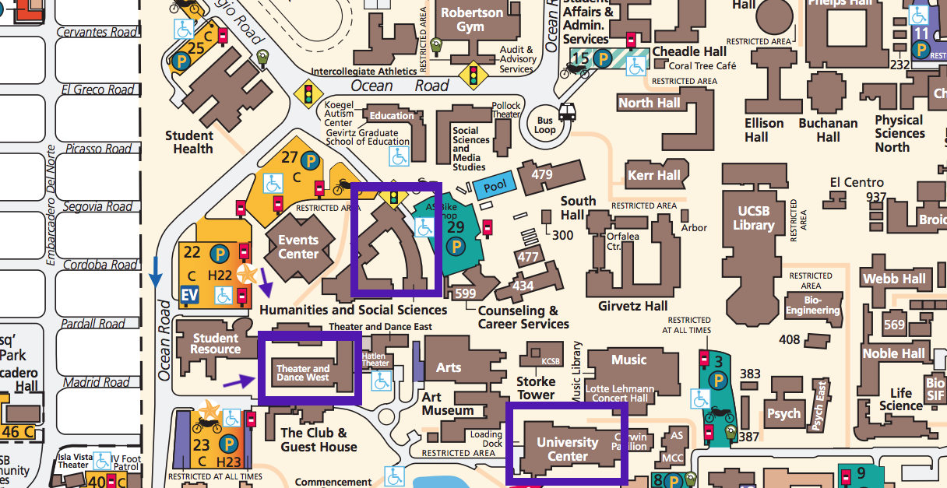

Parking for Commuters to Conference:
Near Humanities and Social Sciences Buildings in lots marked ‘C’
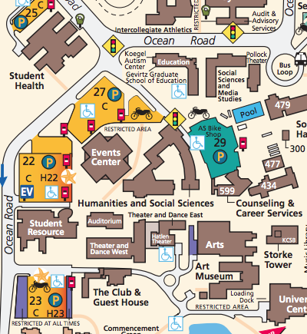

Full map here: http://www.aw.id.ucsb.edu/maps/images/aw_pdfs/Campus_IV.pdf

Air Travel
Santa Barbara Airport
https://www.santabarbaraca.gov/gov/depts/flysba/default.asp

Travel options to/from Santa Barbara Airport to University of California, Santa Barbara campus:

Taxi and shuttle services: (5-minute drive)
- American Taxi - 805-284-7022
- Crown Cab - 805-689-0234
- Fly By Night Taxi - 805-886-8617
- Roadways Cab - 805-683-6200
- Rose Cab - 805-451-0426
- Santa Barbara Airport Taxi - 805-895-2422 (not affiliated with the airport)
- Santa Barbara City Cab - 805-968-6868
- Santa Barbara Checker Cab - 805-560-8284
- Santa Barbara Yellow Cab - 805-9655111
- Central Coast Shuttle - 805.928.1977 or 800.470.8818
- Road Runner - 805.389.8196 or 800.247.7919

Bus service:
There is a Public Bus Stop on Moffett Road across from the Airline Terminal. Bus Schedules are available in the Terminal south lobby and online at http://www.sbmtd.gov/

Car

Travelling South on the US 101 Freeway
Exit the 101 Freeway at the Storke Road / Glen Annie Road (Exit 108) off-ramp (approximately 12 miles north of Santa Barbara).
Turn right onto Storke Road and continue to El Colegio Road.
Turn left onto El Colegio Road and proceed to Ocean Road.
Turn left onto Ocean Road and continue to Mesa Road.
Turn right onto Mesa Road and proceed to the traffic signal at University Plaza.
Turn right into University Plaza and continue to the Information Kiosk (in the center of the plaza) for special event parking instructions, or simply park in a visitor lot and purchase a permit to be displayed in your vehicle.

Travelling North on the US 101 Freeway
Exit the 101 Freeway at the Airport / UCSB (Route 217) off-ramp (approximately eight miles north of Santa Barbara) and proceed through the Henley Gate at the east campus entrance.
Veer right onto Mesa Road and continue to the traffic signal at University Plaza.
Turn left into University Plaza and continue to the Information Kiosk (in the center of the plaza) for special event parking instructions, or simply park in a visitor lot and purchase a permit to be displayed in your vehicle.

Don’t Forget: A permit must be displayed on the dashboard of your vehicle while on-campus.

Train
The Amtrak train station closest to UCSB is the Goleta station (GTA), located at 25 S. La Patera Lane. The Santa Barbara station (SBA) is at 209 State Street. Amtrak’s Pacific Surfliner® stops at the Goleta and Santa Barbara stations, while the Coast Starlight® stops only at the Santa Barbara station.
http://www.tps.ucsb.edu/commuter-options/commute-rail

RideShare
If you would like to be added to the rideshare list via Googledocs, please email Ellen at operations@bmcassociation.org.

Weather:
The weather is usually sunny (between 70-80 degrees). You can track the weather at www.weather.com

What to bring/what to wear:
We recommend, if possible, you bring a yoga mat, water bottle, light blanket, and any vitamins, supplements or medications you need. You may also need a light raincoat, light jacket, and rain boots. For the conference, wear comfortable, layered clothes for movement and temperature adaptation.

Photography/Videography Policy
Please be advised that no photography or videography will be permitted in any workshops or conference offerings. Only BMCA-hired or appointed photographers/videographers will be permitted to take photos or videos in any workshop or at any conference event. Photographs are permitted outside of designated workshop spaces by all participants.

Cancellation Policy
In the unlikely event that the 2019 BMCA Conference will need to be cancelled, BMCA will refund the costs of the conference and any reserved housing back to the participant as soon as possible.
No refunds will be given for participant's cancellations after April 15, 2019.
Liability and Insurance:
The Conference organizer, BMCA, and any suppliers, representatives or agents linked to the organization of the Conference shall not be held liable by any person for any injury, damage, theft, loss, medical problem or inconvenience which may be suffered by any person while traveling to or from, or during such person’s presence in Santa Barbara in connection with this Conference.
Cancellation or Modification of the Conference due to Force Majeure:
In case of force majeure, the Conference organizers have the right to alter or cancel the Conference without prior notice, however a notice of the occurrence shall be given by BMCA as soon as reasonably possible. Force majeure shall mean any circumstance beyond the reasonable control of BMCA which prevents or impedes the holding of the Conference, including, but not limited to, government action, war or hostilities, riot or civil commotion, plague or other epidemic such as SARS, bird flu, etc, earthquake, flood, hurricane, cyclone, fire or other natural physical disaster, explosion, volcano eruption, accident or breakdown, strike, lack of the usual means of transportation or terrorism or due to events which are not attributable to wrongful intent or gross negligence of the BMCA. BMCA shall not be liable for any direct or indirect, incidental or consequential damages, losses, expenditures or any other inconveniences or costs caused by such modification or cancellation of the Conference.
Disclaimer:
All reasonable endeavors will be made to hold the Conference and to present its program as scheduled under circumstances which assure the comfort and safety of all participants and their guests. However, BMCA reserves the right to modify the program, unilaterally and without notice.
Neither BMCA, nor their officers, directors, employees, representatives or agents, shall be held liable by any person as a result of the cancellation of the Conference or any of the arrangements, programs or plans connected therewith, or for any injury, damage or inconvenience which may be suffered by any person while traveling to or from, or during such person’s presence in Santa Barbara in connection with this Conference.

Wi-fi and Cell phone coverage
There will be free wi-fi available in the conference buildings. The network information will be posted at the Conference Registration desk and sent via email prior to the conference. Cellphone coverage is very good on campus. You may want to bring an Ethernet cable if you are staying on campus for better service in your room.

Contact Information and quick info sheet:

UCSB main phone number: 805-893-8000

Erica Howard Erica@bmcassociation.org
BMCA Co-Conference Administrator

Kim Sargent-Wishart Kim@bmcassociation.org
BMCA Co-Conference Administrator

Toni Smith, tsmith818@nycap.rr.com
Conference Committee Chair

Conference Location: Humanities and Social Sciences Buildings
University of Santa Barbara, CA

Conference Dormitory: Sierra Madre Apartments
805-893-3072

Body-Mind Centering® and are registered service marks and BMCSM is a service mark of Bonnie Bainbridge Cohen, used with permission.

